Jaclyn Paez
Workshop SQL Music Shop

Task 1: Basic Selection: Retrieve the titles and release dates of all songs released in 2022, ordered by release date (newest first).
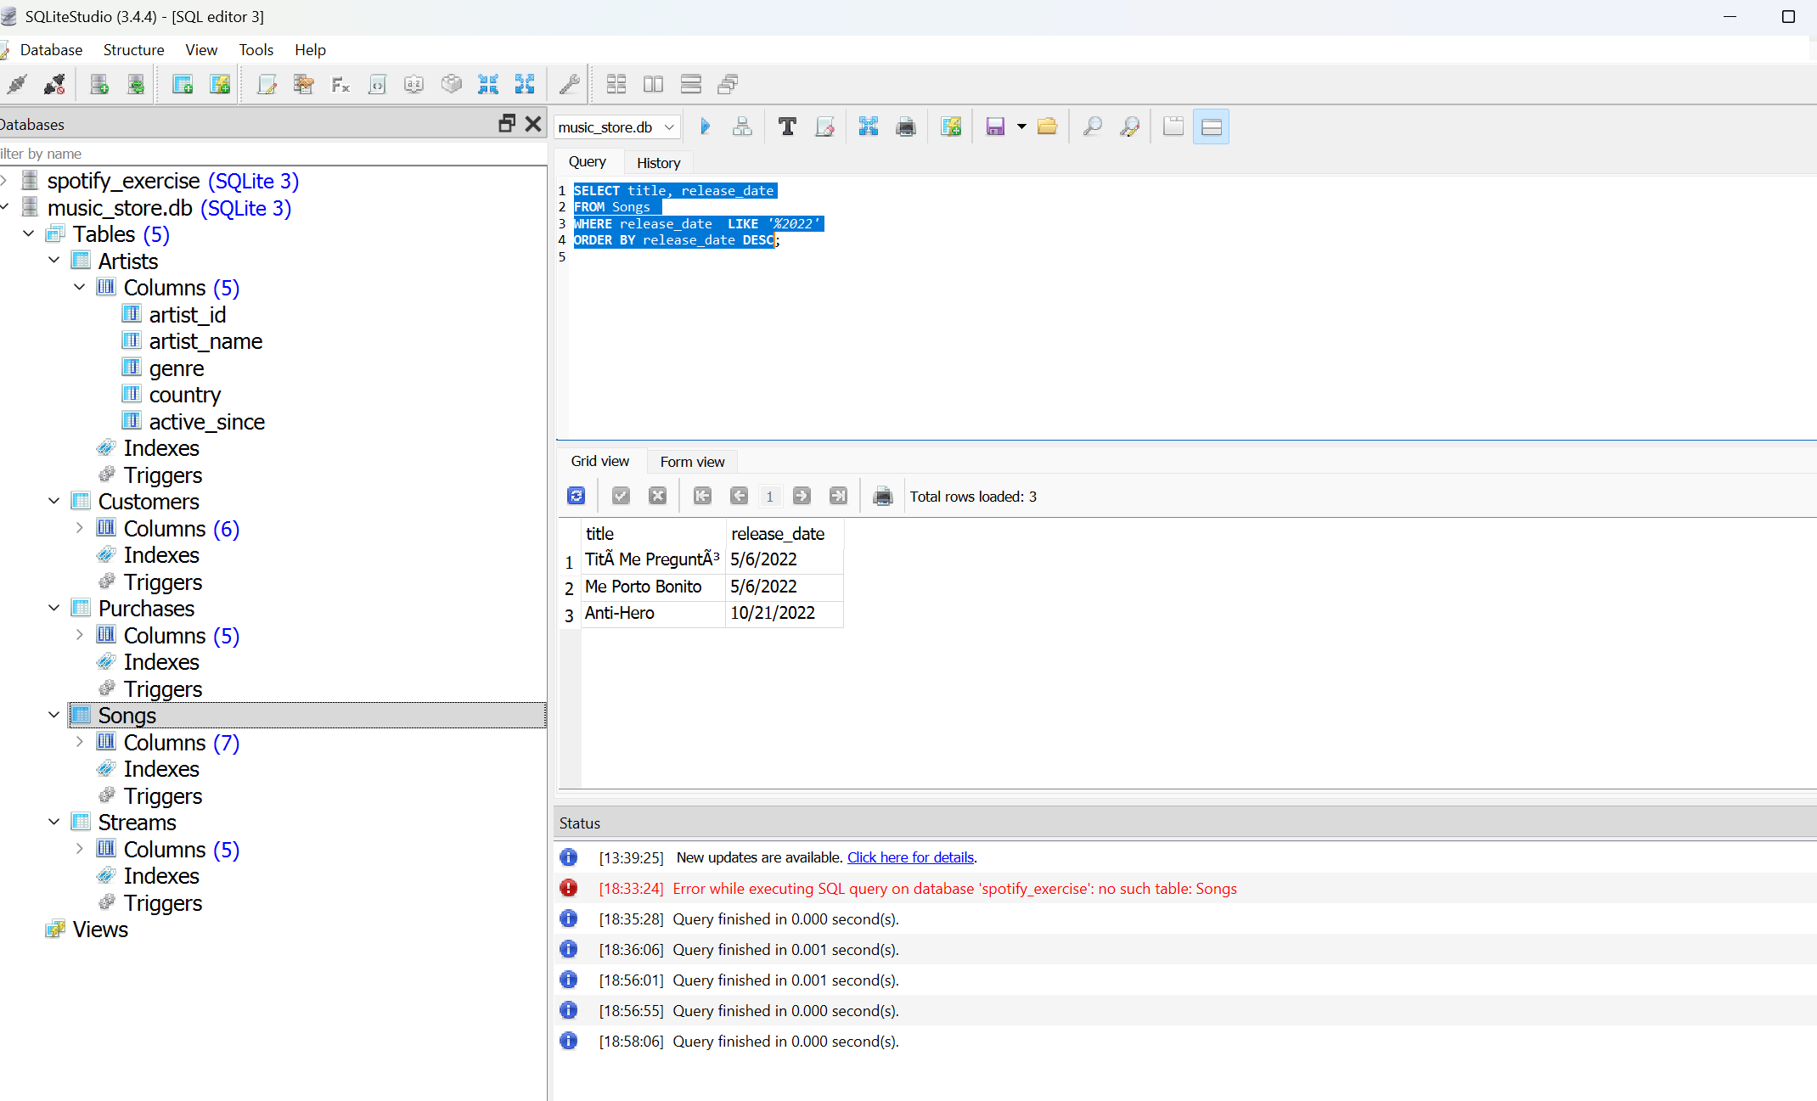

Task 2: Filtering: Find all songs with a popularity score greater than 80 and a duration less than 4 minutes (240 seconds).

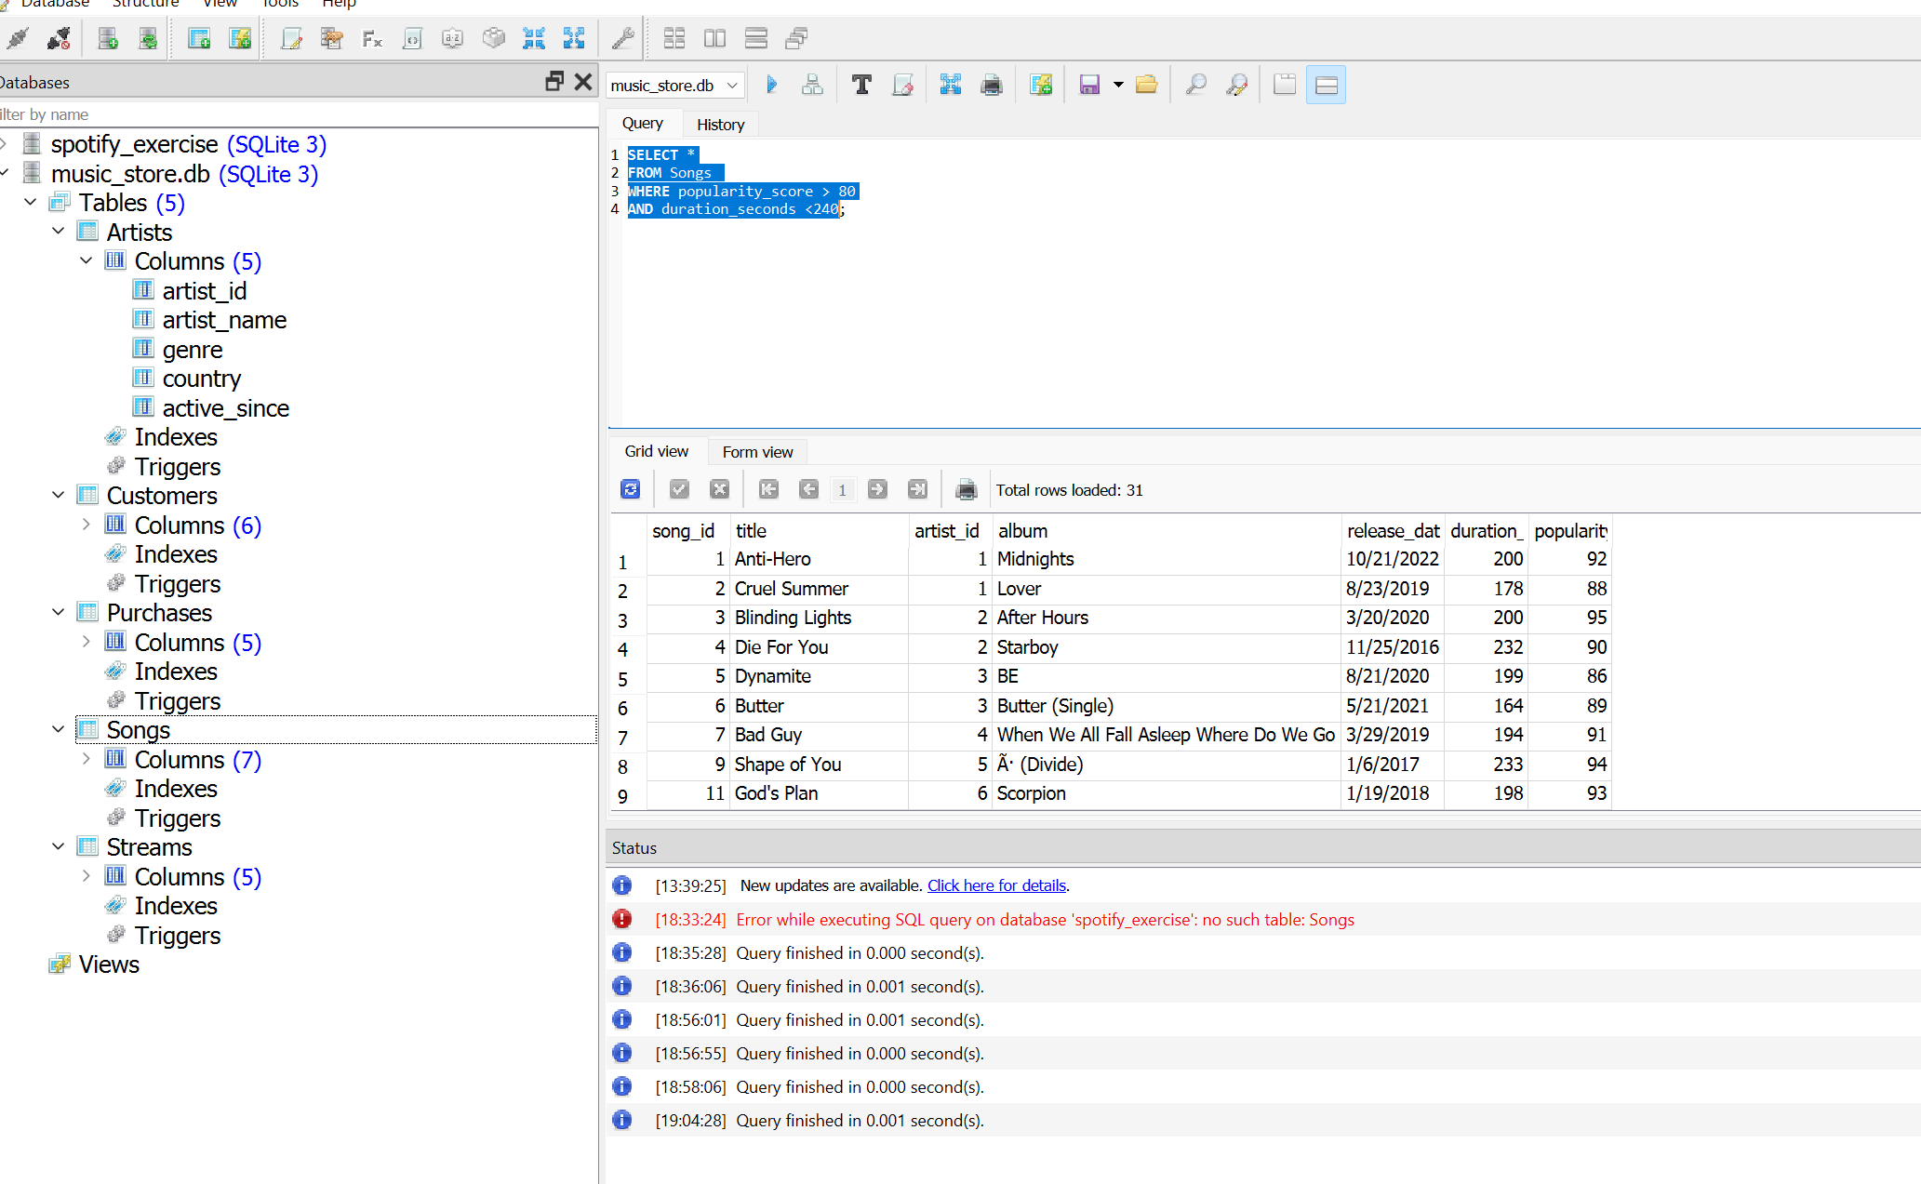

Task 3: Pattern Matching: List all artists whose names start with "The".

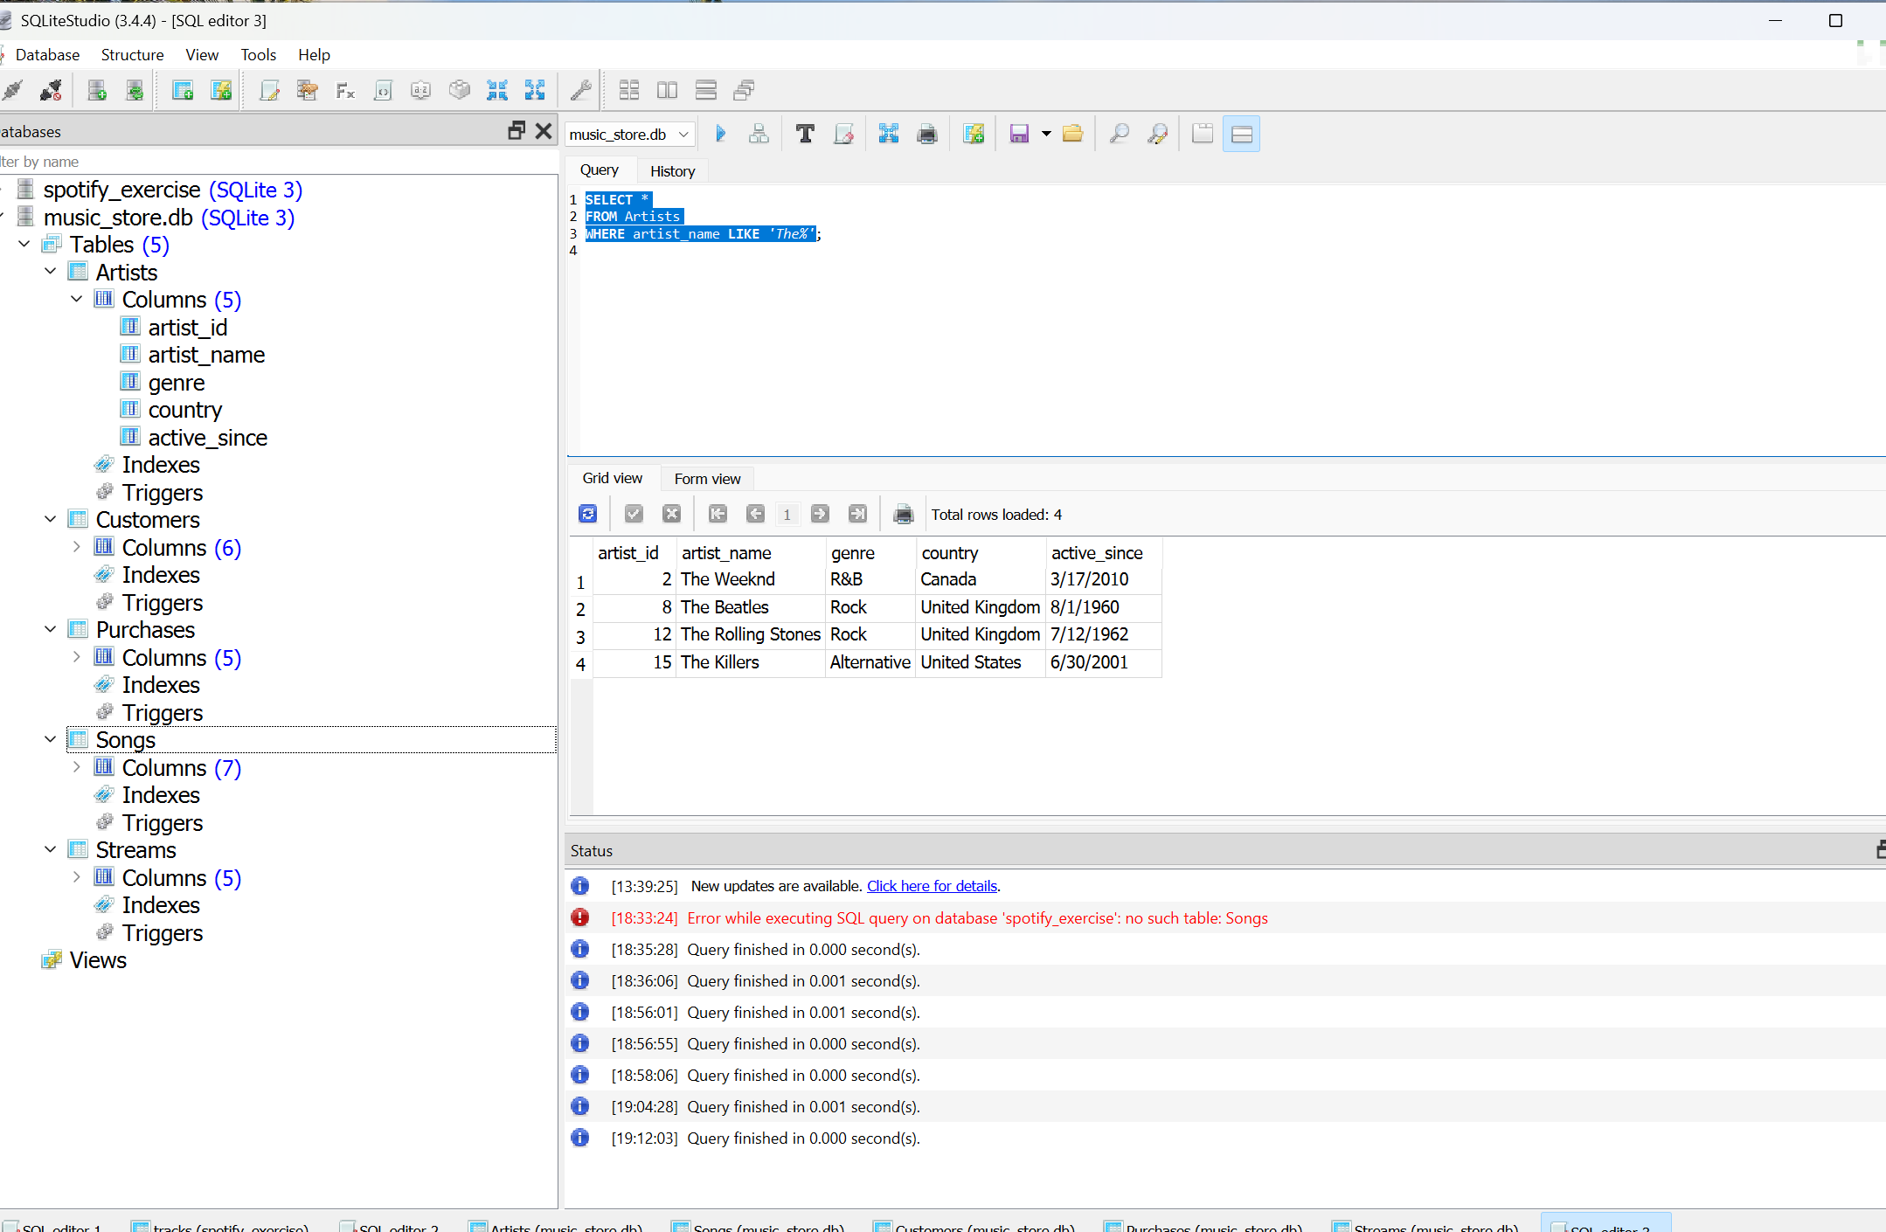

Task 4: Multiple Conditions: Find all premium customers who joined in 2022.

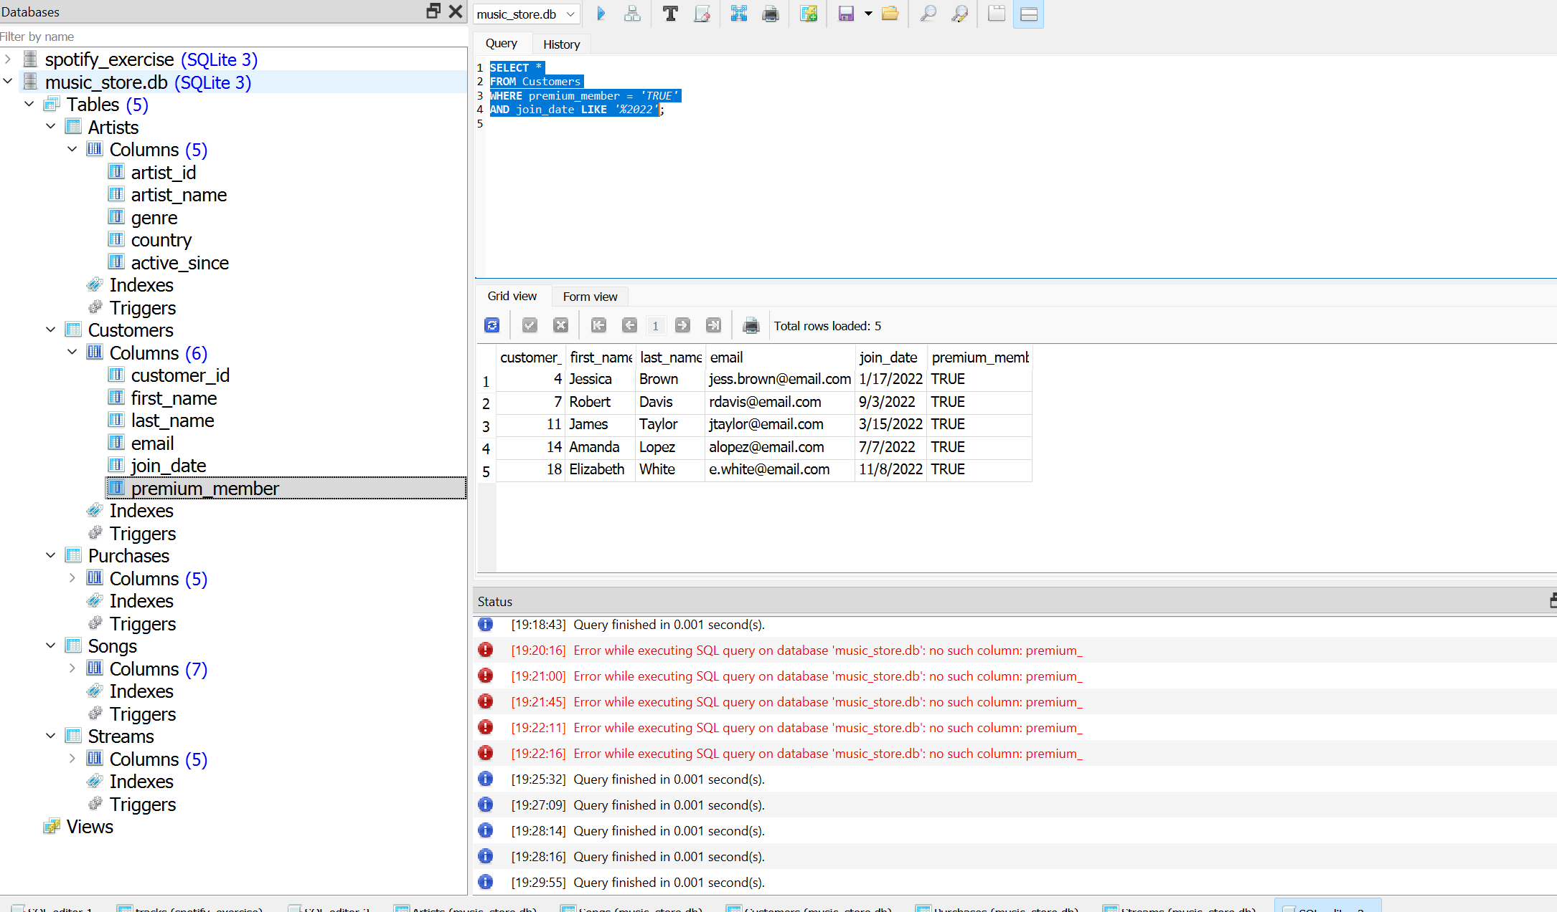

Task 5: Calculations and Aliasing: Calculate the total duration (in minutes) of all songs in the database and display the result with an appropriate column name.

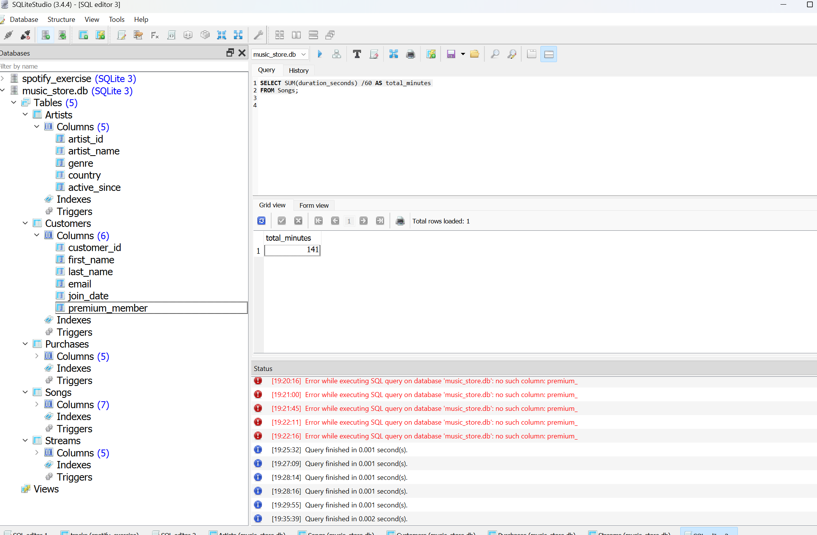
Task 6 : Advanced Filtering: Find the top 5 most expensive song purchases in the database.

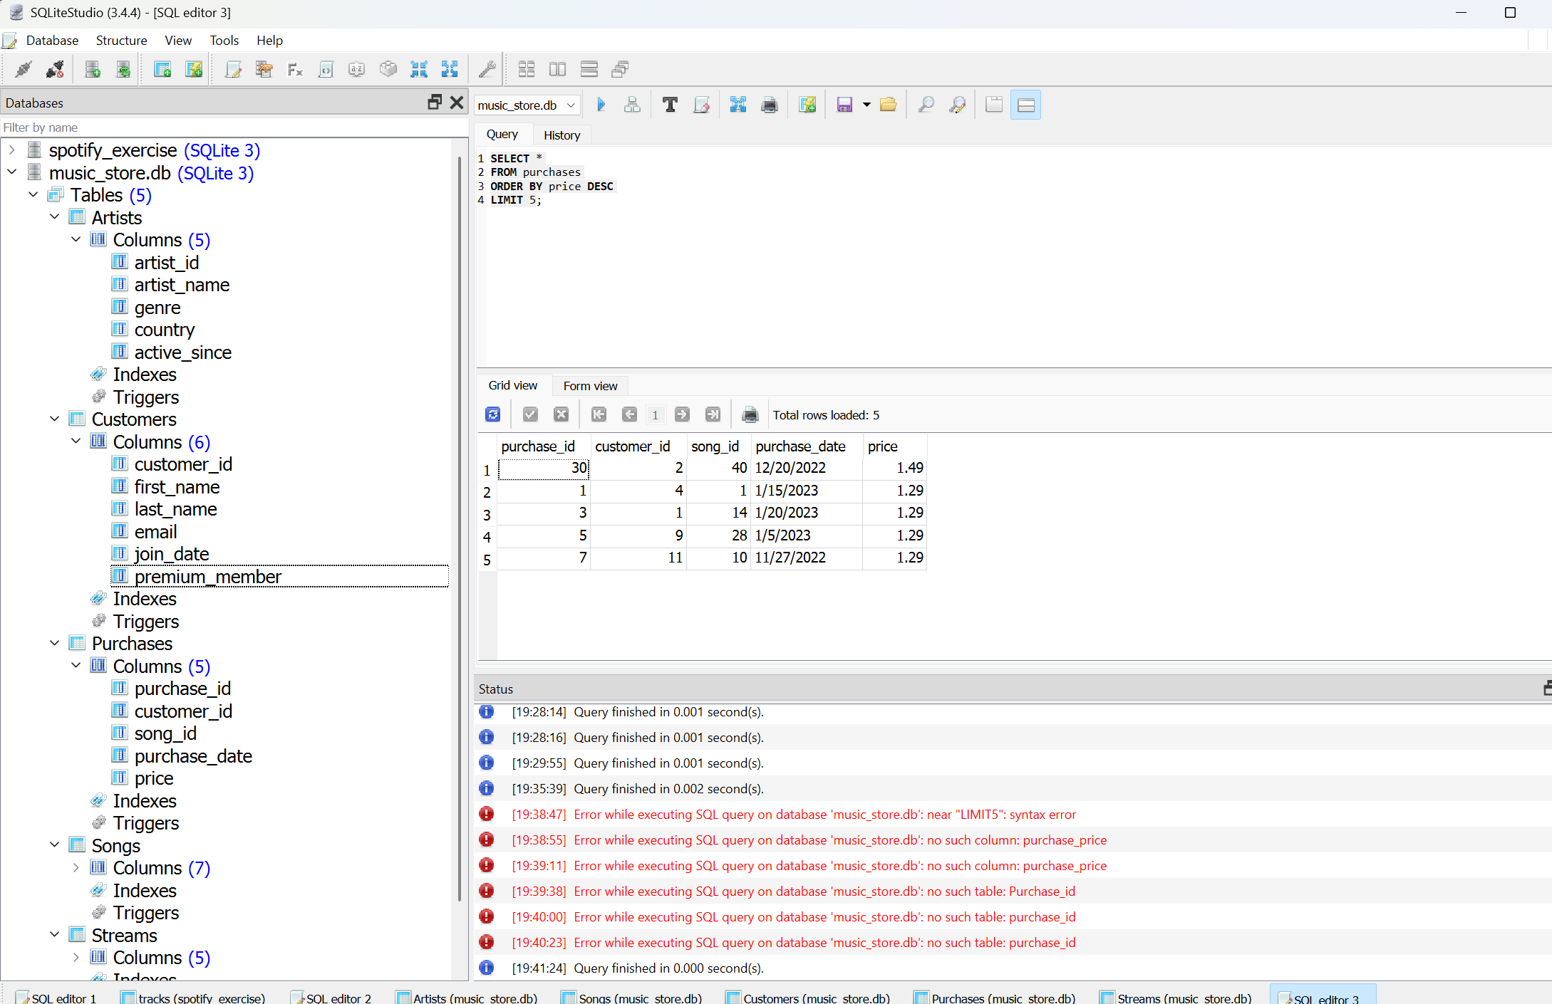

Task 7: Find all purchases for songs with a popularity score above 90

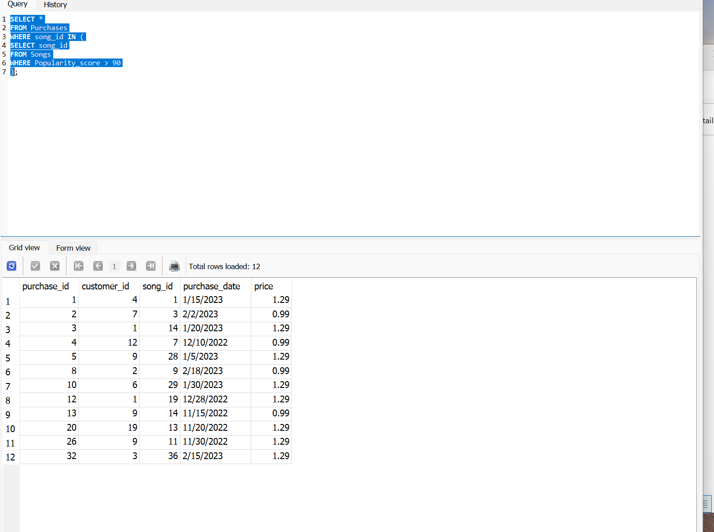

Task 8: Range Checking: Find all purchases made between January 1, 2023 and March 31, 2023
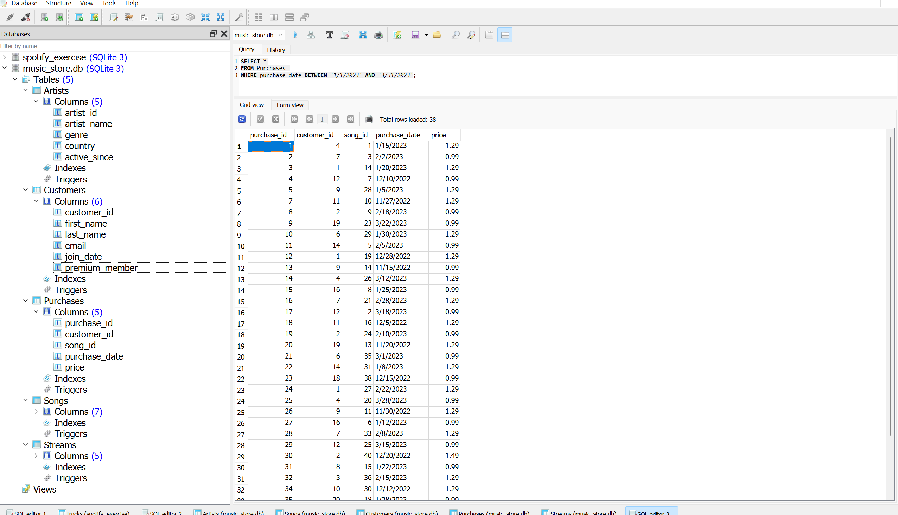

Task 9: Advanced Filtering with ORDER BY: Identify the songs with the highest popularity scores (above 90).

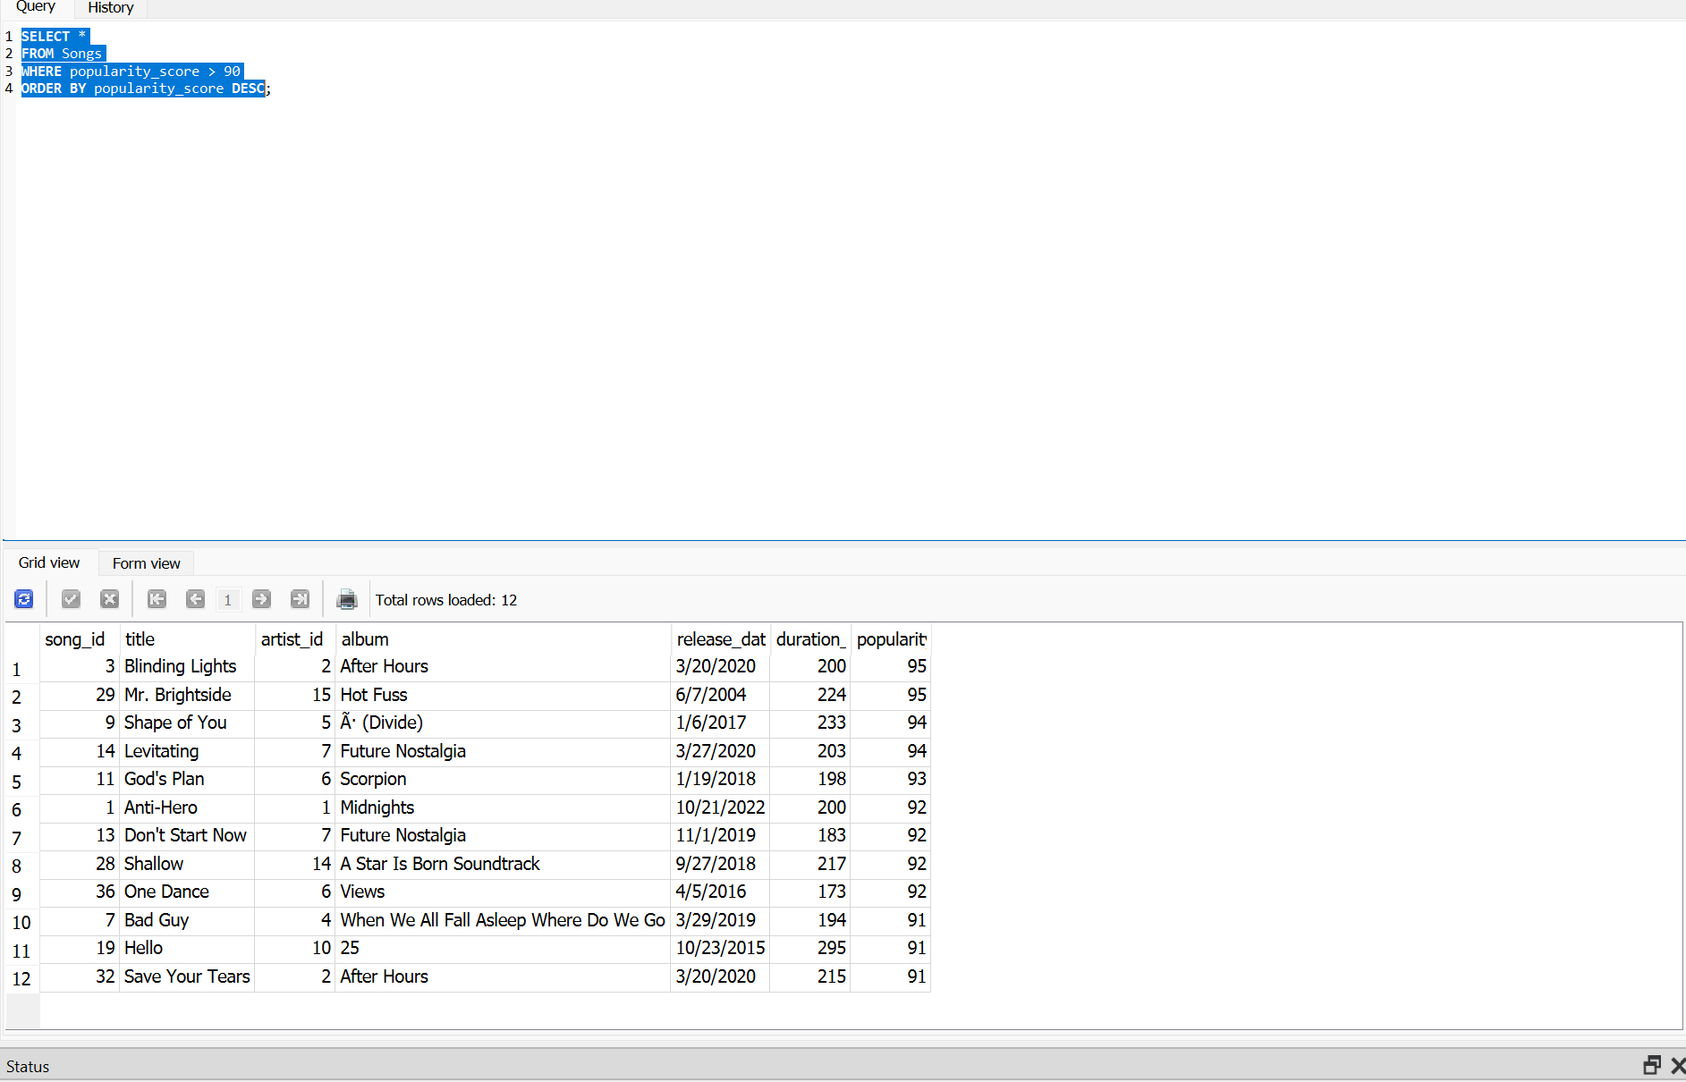

Question 1
Why separate Purchases and Streams into different tables?
I think separating Purchases and Streams into different tables makes the database more organized and easier to manage. Even though both involve songs, they represent different types of user activity. Keeping them separate allows you to track purchases and streaming behavior independently, avoid duplicate data, and make reporting and analysis more accurate.

Question 2
What business questions could SQL answer?
Based on the data provided, SQL could help answer a lot of useful business questions. For example, we could identify which songs or artists are the most popular, which songs generate the most purchases, how many premium members are using the platform, and what trends exist in customer listening and purchasing habits. This information could help the business make better marketing and content decisions.

Question 3
How would you extend the schema to track song skips?
To track song skips, I would add a new table specifically for skip activity. It could include the customer ID, song ID, date and time of the skip, and how much of the song was listened to before it was skipped. This would provide additional insight into listener behavior and help identify songs that users frequently stop listening to before they finish.

Question 4: For tasks 1-3, how could you combine them into a single, more complex query that finds popular short songs by artists whose names start with "The"?

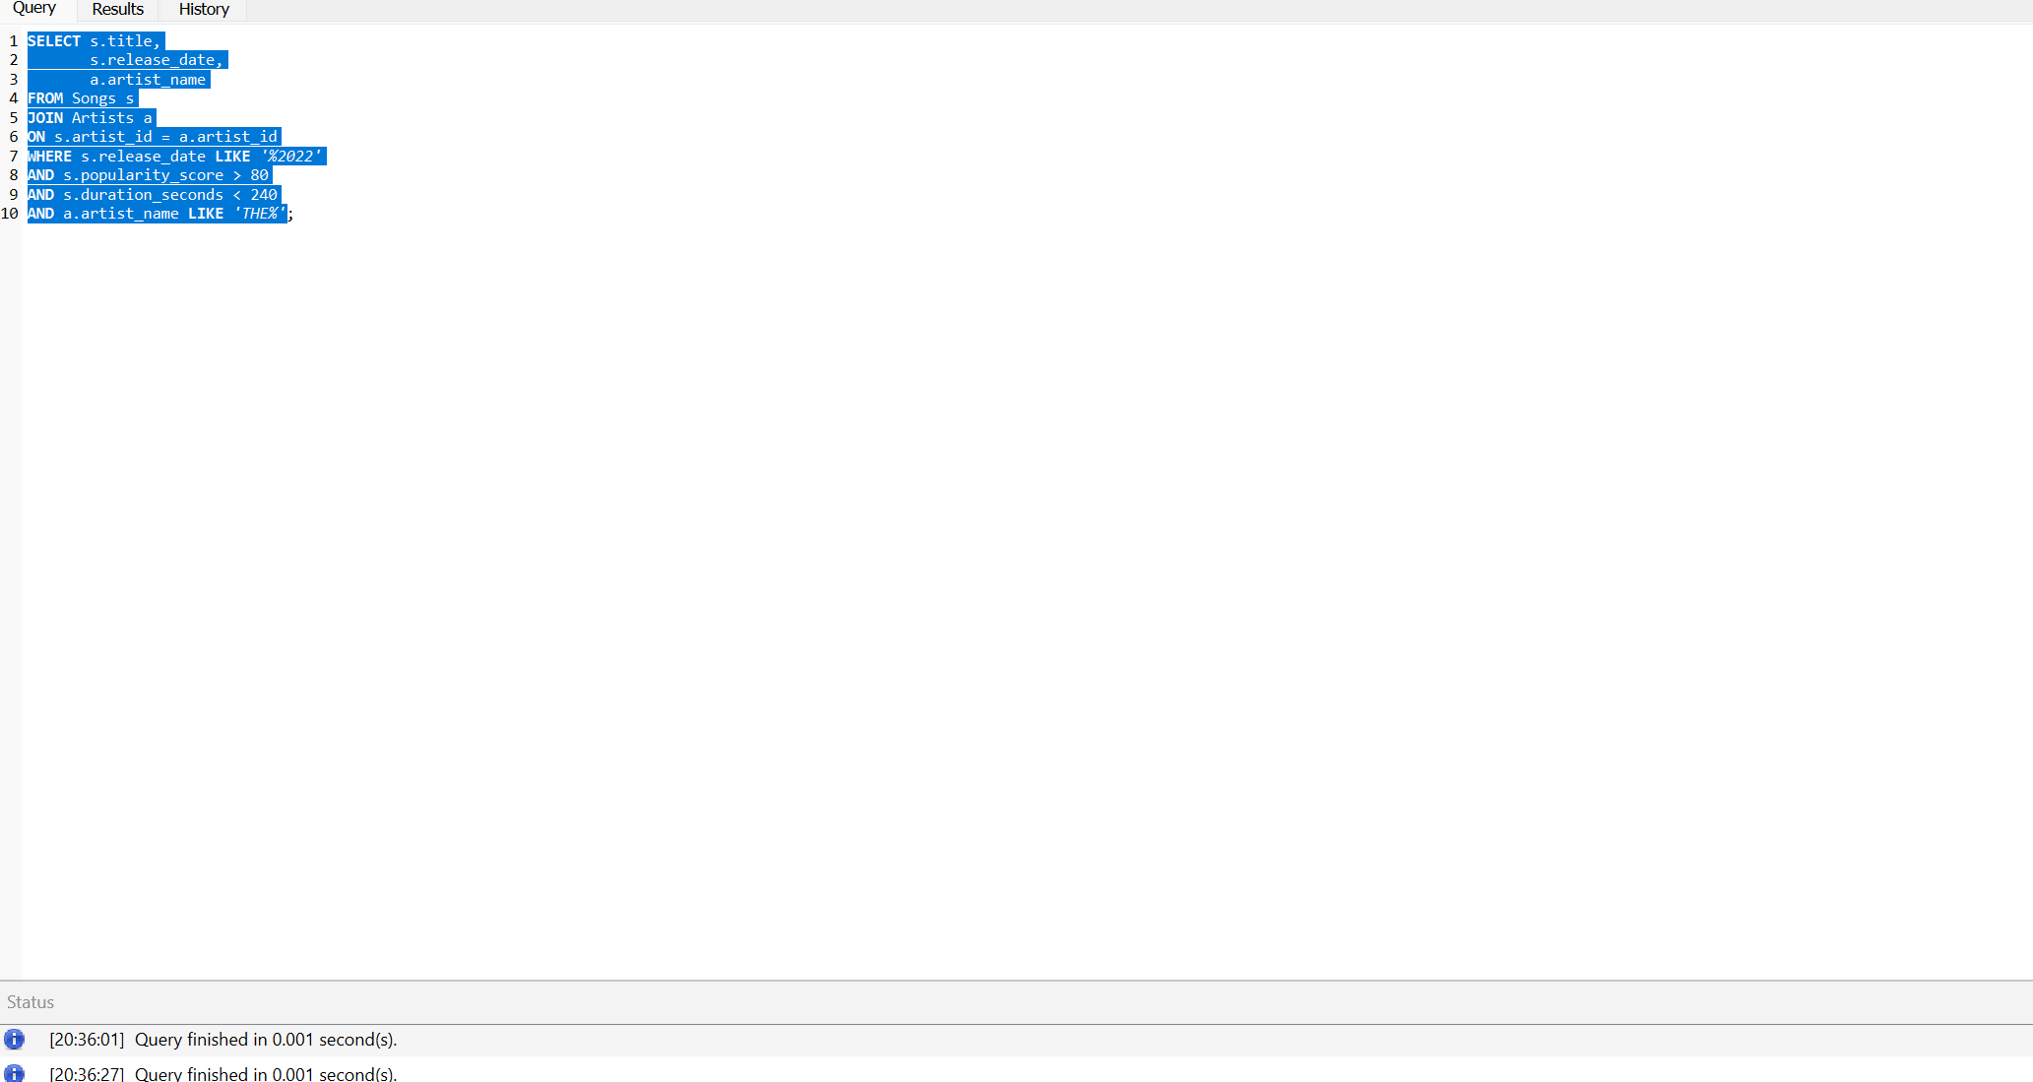

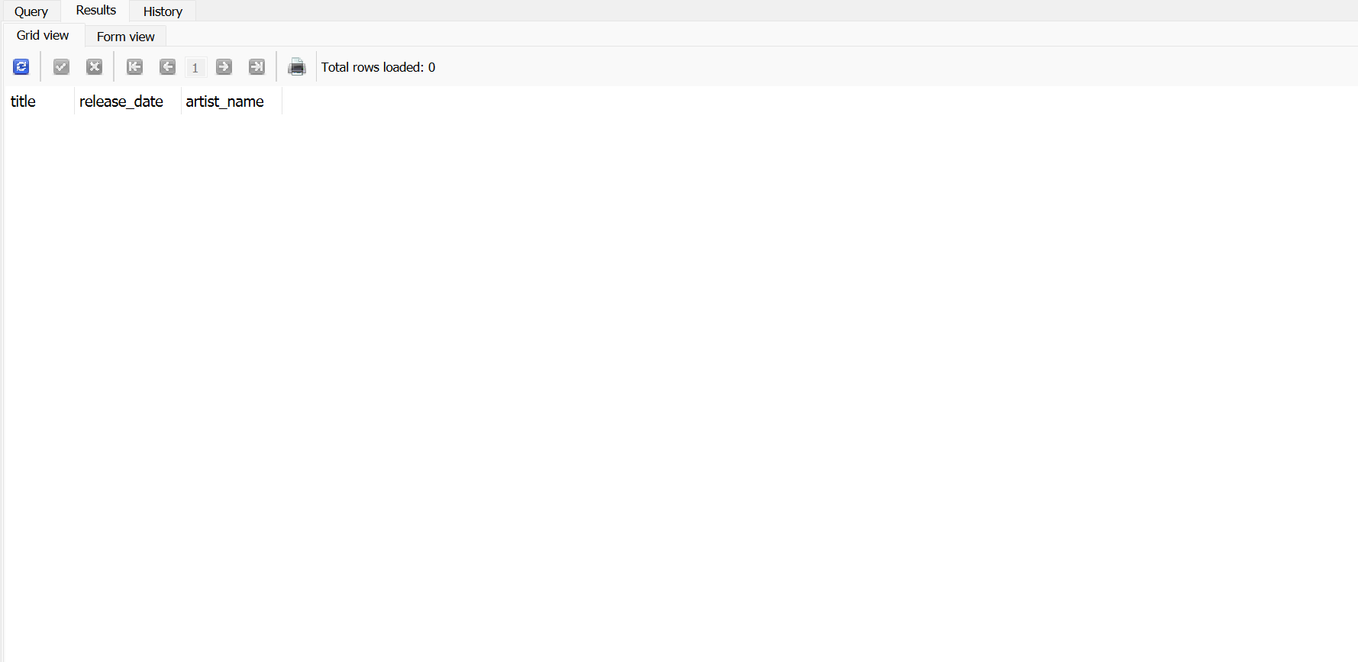

No Rows in Sample Data that meet all these conditions at one time.

